FAQ:

It is glad to hear your feedback on this app. Please email your feedback to [extremepestcrew@gmail.com.au](mailto:extremepestcrew@gmail.com.au).

**I do not know how to add location for pests?**

You can search a specific pest in the search bar  of the home page, or tap species icon enter to the species list. By tap any of species you can jump into the detailed information page and you can find an add location button , which is at the bottom of the page. By tap this button, a pop up window 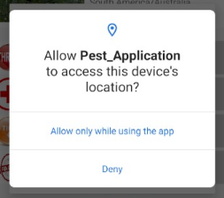will ask your consent about whether use the current location for pest location or you can add the location manually 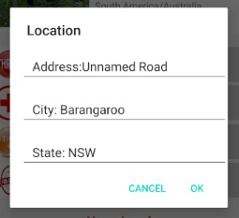 .

**Why added pest location unable to display in the map?**

Once you fill up the form, your data will be store in the database. Which will take 5-15 minutes to upload. You can refresh the map and see a new marker after 10-30 minutes.

**What is harm score, why would I use it?**

The harm score represents a predefined harmfulness of each listed species, you can play with it and select a score that you think it is the most appropriate level of harmfulness. Your selection will be recorded into the database and the harm score will updated weekly.